

We use Hero as one of our main communication tools. Hero is a secure learning and administration platform for us to share learning and communicate with our school whānau.
Through the app, you can receive newsletters and notices, advise of absences,
access student billing, and view your child’s school reports.

Download the Hero App today!

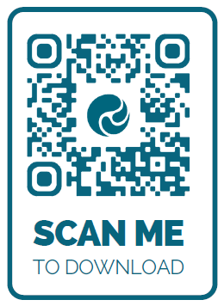

Ready, set, sign in! Stay in the loop by following these steps: https://our-hero.com/parent-guide
Hero can also be accessed through your desktop: https://go.linc-ed.com/

If you need any additional help, feel welcome to email office@owhiro.school.nz or stop by and see us.

